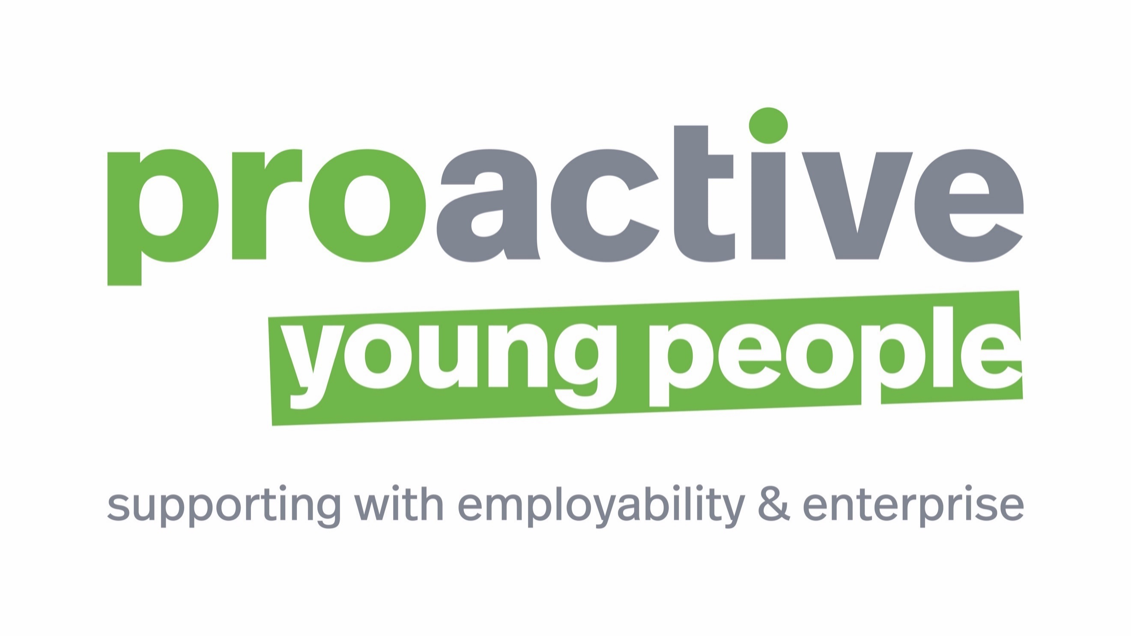

Student Name

Male or Female

Placement Dates | Monday 3rd June – Friday 7th June
Placement Job Title
Main Duties
Please provide a sentence or two regarding what the student will be doing

Company Name
Contact (First & Last name)
Position
Phone Number
Email Address - BLOCK CAPITALS PLEASE
Address (of placement)
Inc. Post Code
Do you have Employers Liability Insurance | Yes / No*
Does the student have a relative working for this company | Yes / No*

*If both are a NO this form will likely be rejected

Proactive Young People C.I.C will contact the person named above to arrange a physical visit

Please sign to agree to take this student into your business

If agreed over the phone please forward an email confirmation to info@proactiveyoungpeoplecic.co.uk

Please ask your Parent / Carer to complete this side of the form
Please complete the table below to add any information that you feel would help the employer to support your child on work experience.
 | Yes/No | What support, if any, would help your child when completing their work experience placement?
Does your child have any special educational needs or disability (e.g. Dyslexia, ASD, Visual, Hearing or Physical impairment)?

Does your child have any health needs (e.g. Asthma, Diabetes, Allergies)?
Is your child confident in an English-speaking environment?
Any other comment:
Parent Carer Agreement to Placement
Please read the following guidelines before signing below.
Job Choice – This should be discussed with your child and agreed by the parent/guardian.
Travelling/Fares – Please note that fares are not normally reimbursed and also that it is the responsibility
of parents and students to ensure that they can make suitable travel arrangements.
Lunches – These are not normally provided.
Please note: Once this section is signed and received by the WRL team at school, any change/cancellation by you or your child will incur an administrative charge, charged by the school.
Parent Name (please print) |  | Date
Parent Signature
Parent Email – BLOCK CAPITALS PLEASE
Please use your child’s username and password to review the contract and full placement details after the visit by Proactive Young People. (Issued by the school but can be reset via www.pypcic.co.uk)

